**Assignment 2 - Scenario 1**

**Introduction -**

This report will demonstrate the configured Network Security measures for the corporate environment. It shows Configured Network Security for the network. It will discuss different cryptographic types of Network Security and provide Network Security configuration scripts/files/screenshots with comments. It will also discuss what is meant by Quality of Service (QoS) in relation to Network Security configuration.

Design model for Scenario 1 -

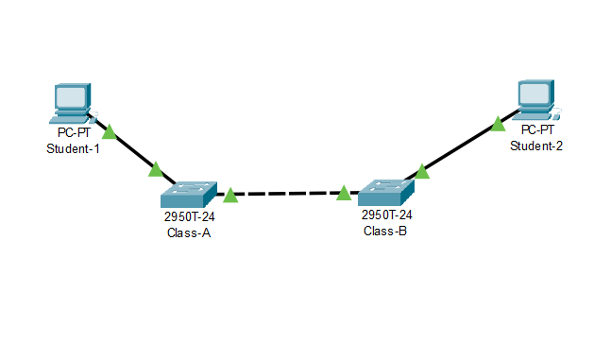

**Hostname for the Switch -**

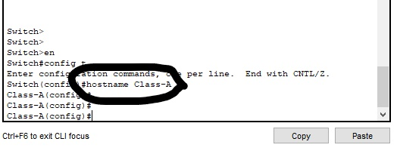

Name **Class-A** and **Class-B** switches.

**Class A -**

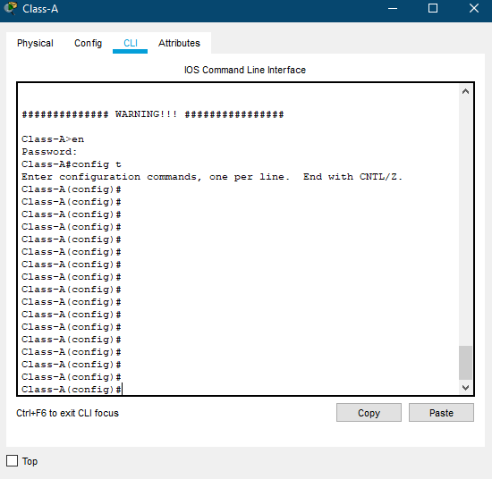

**Class B -**

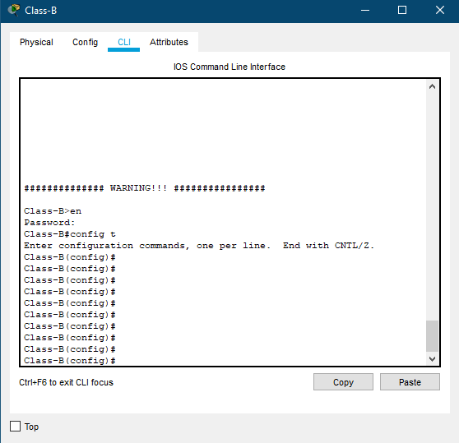

Using the **8ubRu** password for all lines.

**Telnet Line Password -**

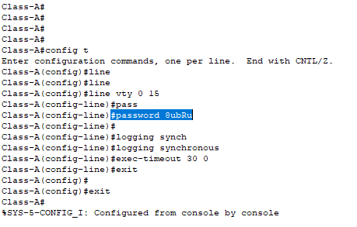

**Testing telnet line password -**

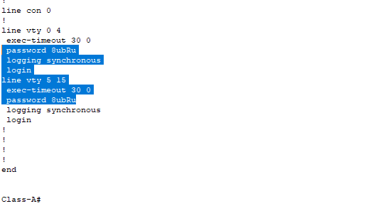

**Console Line Password -**

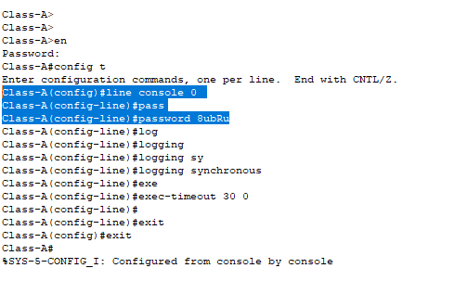

**Testing console line password -**

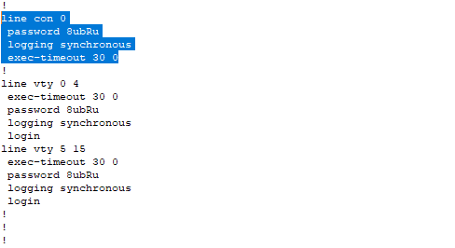

Use the **C9WrE** secret password.

**Enable Secret Password -**

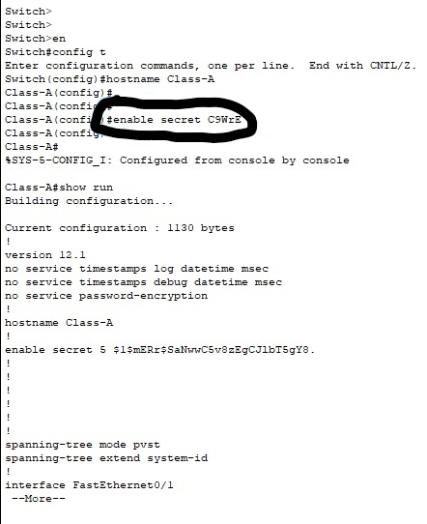

**Testing enable secret password -**

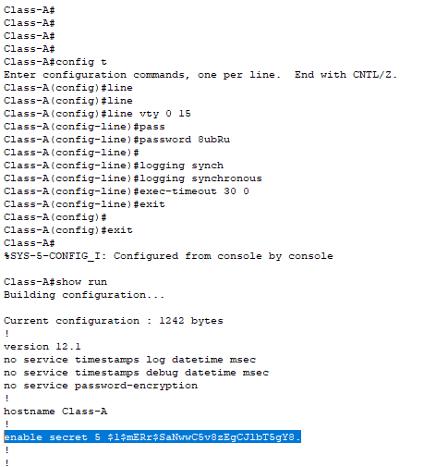

Banner message ‘**warning’** in the message-of-the-day (MOTD).

**Banner Message -**

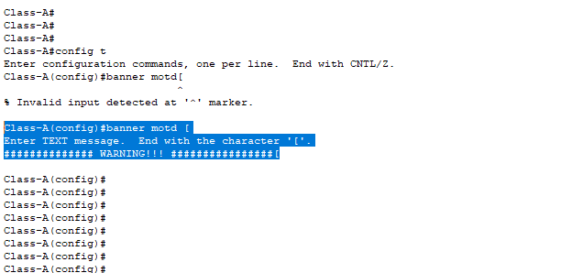

**Testing Banner Message -**

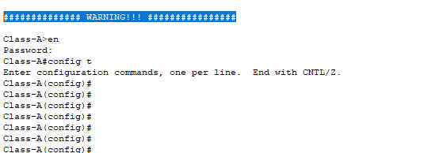

Configurations of addresses based on the addressing table -

**Student 1 address table -**

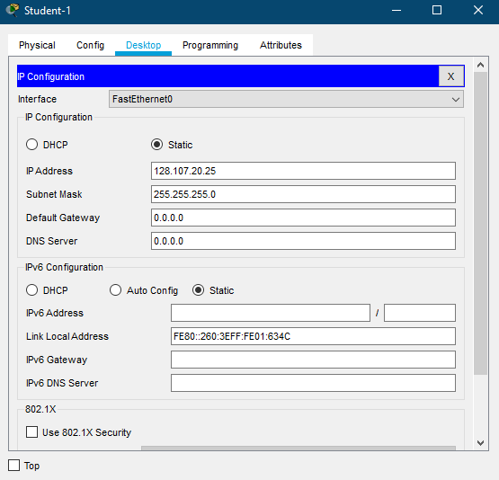

**Student 2 address table -**

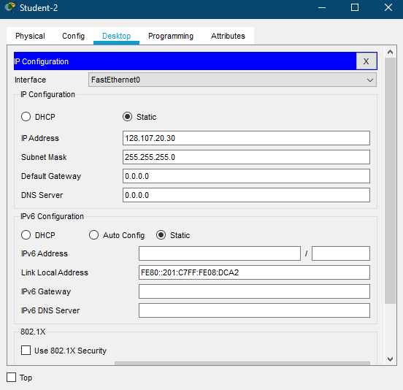

**Class A setting ip address -**

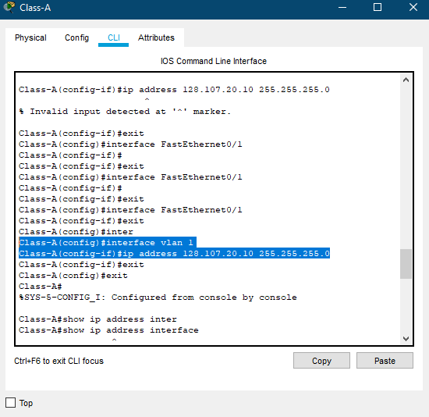

**Testing show ip for Class A -**

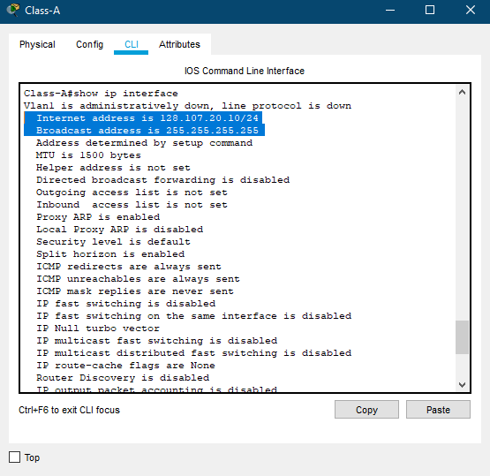

**Class B setting ip address -**

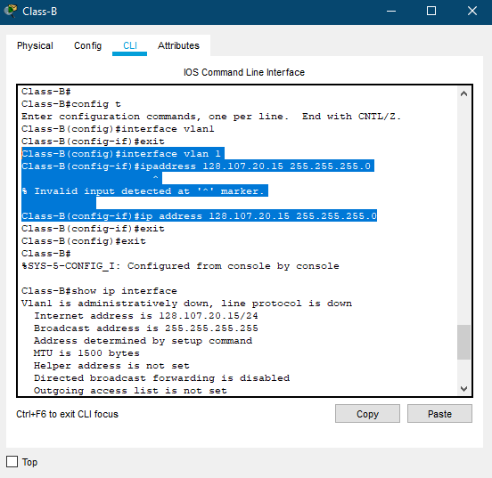

**Testing show ip for Class B -**

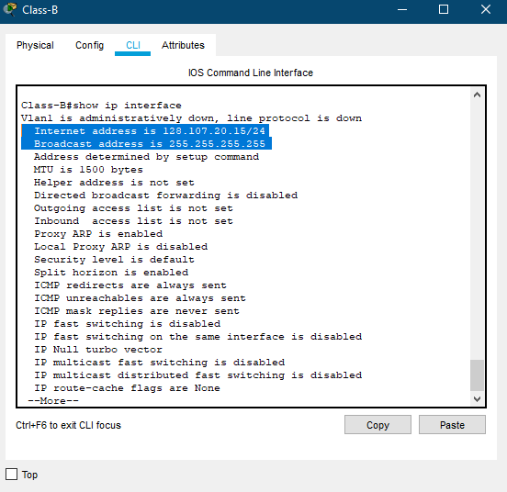

**Setting vLan 1 for Class A -**

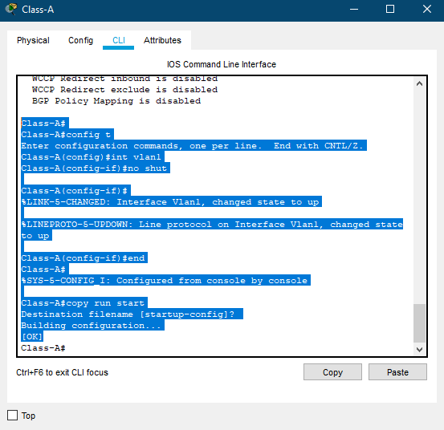

**Setting vLan 1 for Class B -**

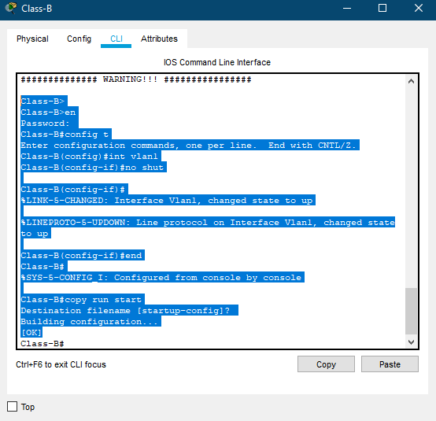

**Verify connectivity between all devices.**

Ping testing **Student 1** to **Student 2** -

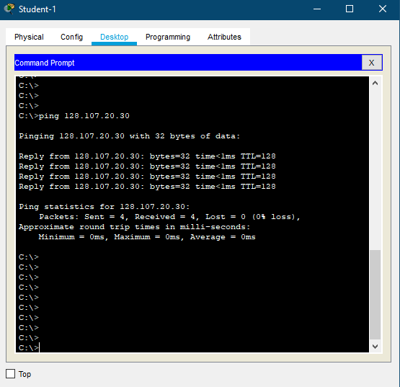

Ping testing **Student 2** to **Student 1** -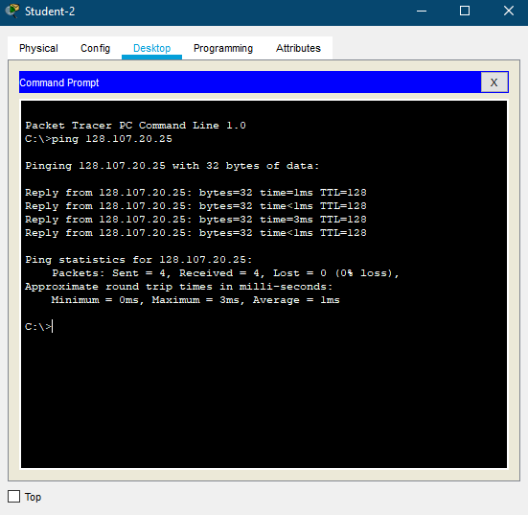

Ping testing **Student 1** to **Class A** -

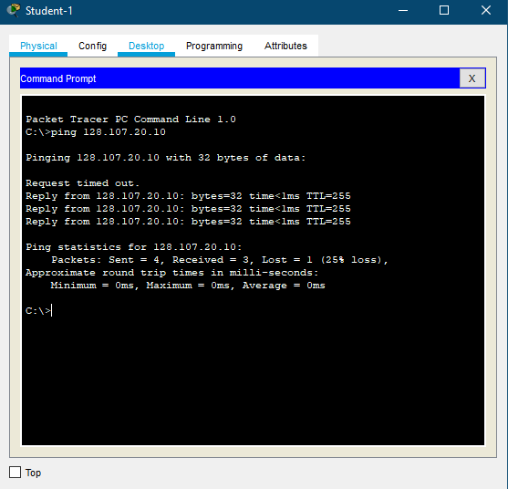

Ping testing **Student 1** to **Class B** -

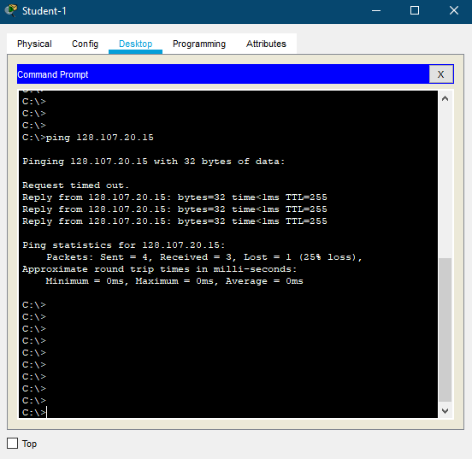

Ping testing **Student 2** to **Class A** -

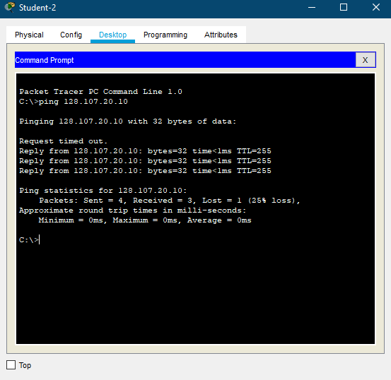

Ping testing **Student 2** to **Class B** -

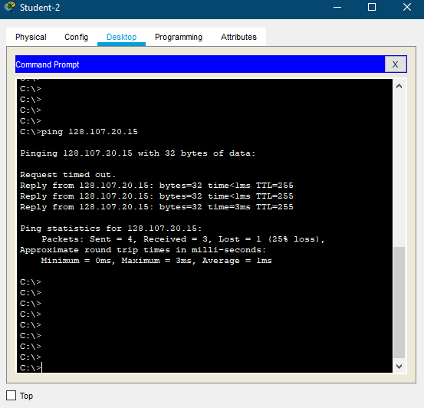

**Discuss what is meant by Quality of Service (QoS) in relation to Network Security for above network configuration.**

**Quality of Service (QoS) -**

The term ‘quality of service’ has the primary goal of service quality is to give priority to networks, including dedicated bandwidth, controlled jitter, low latency, and enhanced loss features. The innovations include the basic building blocks that will be used for potential business applications in campus, small area networks and networks of service providers.

The basic QoS implementation has three fundamental components:

* Identification and marking techniques to coordinate the QoS between network elements from end to end.
* QoS inside a single feature of a network.
* QoS regulation, management and accounting responsibilities for monitoring and managing end-to - end network traffic.

**Characteristics of QOS based on the network configuration -**

**Bandwidth -**

The various applications need the specific bandwidth. For instance:

Video conferencing requires more bandwidth compared with sending an email.

**Jitter -**

The jitter is the delay variable in the packet. When there's a major gap between delays then it's called high jitter. On the contrary, it is known as low jitter, if the difference between delays is slight. For Instance : If 3 packets 0, 1, 2 are sent and received at 31, 34, 39, so the delay is different for all packets. In this case, the time delay is not acceptable for the telephonic conversation.

**Delay -**

A very critical feature is delay of a message from source to destination. Nevertheless, the varying applications will handle delay differently.

For instance: In audio conferencing the time delay can not be tolerated (needs a minimum time delay), while the time delay in e-mail or file transfer is less significant.

**Reliability -**

If a packet gets lost or acknowledgment is not received (at sender), the data would need to be retransmitted. This reduces efficiency.

According to the application the value of reliability can differ.

For instance:

In contrast with an audio call, e-mail and file transfer must provide a secure transmission.

**Integrated and Differentiated Services in QOS -**

These two models are designed to provide the Network with Quality of Service ( QoS).

**Integrated Services( IntServ) -**

Integrated service is a QoS model based on flows and is optimised for IP.

Users need to create a flow in the network of integrated services, from source to destination, and need to notify all routers of the resource requirement (every router in the system implements IntServ).

**Differentiated Services (DS or Diffserv) -**

DS is a paradigm of computer networking intended to achieve scalability through the control of network traffic. It is a class-based QoS model, developed specifically for IP.

IETF (Internet Engineering Task Force) designed DS to address Integrated Services problems.

**QOS in relation to network security -**

Quality of Service in relation to network security is a set of technologies that work on a network to ensure its ability to run high-priority applications and traffic reliably within limited network capacity. QoS systems achieve this by providing differential management and allocation of resources to particular network traffic flows. This allows the network administrator to assign the order in which packets are handled and how much bandwidth that application or traffic flow has been granted.

**Conclusion -**

In conclusion, this report demonstrates the configured Network Security measures for the corporate environment. It shows Configured Network Security for the network. It discusses different cryptographic types of Network Security and provides Network Security configuration scripts/files/screenshots with comments. It also discusses what is meant by Quality of Service (QoS) in relation to Network Security configuration.

**Resources -**

Youtube. 2020. *Cisco Switch Configuration || Host Name, Password & Banner*. [online] Available at: <https://www.youtube.com/watch?v=5Mlts3lFz_4> [Accessed 23 May 2020].

Cisco. 2020. *Configure The Internet Protocol (IP) Address Settings On A Switch Through The Command Line Interface (CLI)*. [online] Available at: <https://www.cisco.com/c/en/us/support/docs/smb/switches/cisco-350-series-managed-switches/smb5557-configure-the-internet-protocol-ip-address-settings-on-a-swi.html> [Accessed 23 May 2020].

Community.cisco.com. 2020. *VLAN 1 Administratively Down, Protocol Down*. [online] Available at: <https://community.cisco.com/t5/switching/vlan-1-administratively-down-protocol-down/td-p/1525093> [Accessed 23 May 2020].

Techopedia.com. 2020. *What Is Quality Of Service (Qos)? - Definition From Techopedia*. [online] Available at: <https://www.techopedia.com/definition/9049/quality-of-service> [Accessed 23 May 2020].

Tutorialride.com. 2020. *Quality Of Service (Qos) In Computer Network*. [online] Available at: <https://www.tutorialride.com/computer-network/quality-of-service-qos-in-computer-network.htm> [Accessed 23 May 2020].

Paloaltonetworks.com. 2020. *What Is Quality Of Service? - Palo Alto Networks*. [online] Available at: <https://www.paloaltonetworks.com/cyberpedia/what-is-quality-of-service-qos> [Accessed 23 May 2020].